PIZZA SALES QUERIES

1. **KPI’s**

## Total Revenue:

SELECT SUM(total_price) AS Total_Revenue FROM pizza_sales;

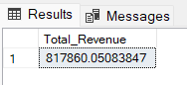

# Average Order Value:

SELECT (SUM(total_price) / COUNT(DISTINCT order_id)) AS Avg_order_Value FROM pizza_sales;

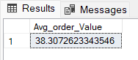

## Total Pizzas Sold:

SELECT SUM(quantity) AS Total_pizza_sold FROM pizza_sales;

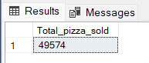

## Total Orders:

SELECT COUNT(DISTINCT order_id) AS Total_Orders FROM pizza_sales;

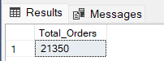

## Average Pizzas Per Order:

SELECT CAST(CAST(SUM(quantity) AS DECIMAL(10,2)) /

CAST(COUNT(DISTINCT order_id) AS DECIMAL(10,2)) AS DECIMAL(10,2))

AS Avg_Pizzas_per_orderFROM pizza_sales;

**B. Daily Trend for Total Orders**SELECT DAYNAME(DW, order_date) AS order_day, COUNT(DISTINCT order_id) AS total_orders

FROM pizza_sales

GROUP BY DAYNAME(order_date);

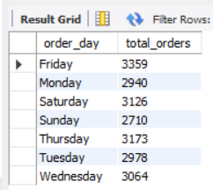

**C. Monthly Trend for Orders**

select MONTHNAME(order_date) as Month_Name, COUNT(DISTINCT order_id) as Total_Orders

from pizza_sales

GROUP BY MONTHNAME(order_date);

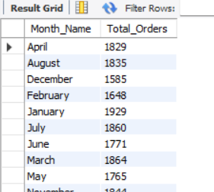

**D. % of Sales by Pizza Category**

SELECT pizza_category, CAST(SUM(total_price) AS DECIMAL(10,2)) as total_revenue,

CAST(SUM(total_price) * 100 / (SELECT SUM(total_price) from pizza_sales) AS DECIMAL(10,2)) AS PCT

FROM pizza_sales

GROUP BY pizza_category;

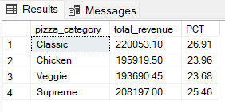

**E. % of Sales by Pizza Size**

SELECT pizza_size, CAST(SUM(total_price) AS DECIMAL(10,2)) as total_revenue,

CAST(SUM(total_price) * 100 / (SELECT SUM(total_price) from pizza_sales) AS DECIMAL(10,2)) AS PCT

FROM pizza_sales

GROUP BY pizza_size

ORDER BY pizza_size

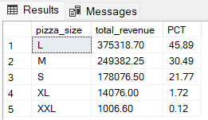

**F. Total Pizzas Sold by Pizza Category**

SELECT pizza_category, SUM(quantity) as Total_Quantity_Sold

FROM pizza_sales

WHERE MONTH(order_date) = 2

GROUP BY pizza_category

ORDER BY Total_Quantity_Sold DESC;

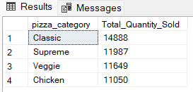

**G. Top 5 Pizzas by Revenue**

SELECT Top 5 pizza_name, SUM(total_price) AS Total_Revenue

FROM pizza_sales

GROUP BY pizza_name

ORDER BY Total_Revenue DESC;

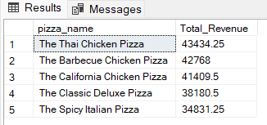

**H. Bottom 5 Pizzas by Revenue**

SELECT Top 5 pizza_name, SUM(total_price) AS Total_Revenue

FROM pizza_sales

GROUP BY pizza_name

ORDER BY Total_Revenue ASC;